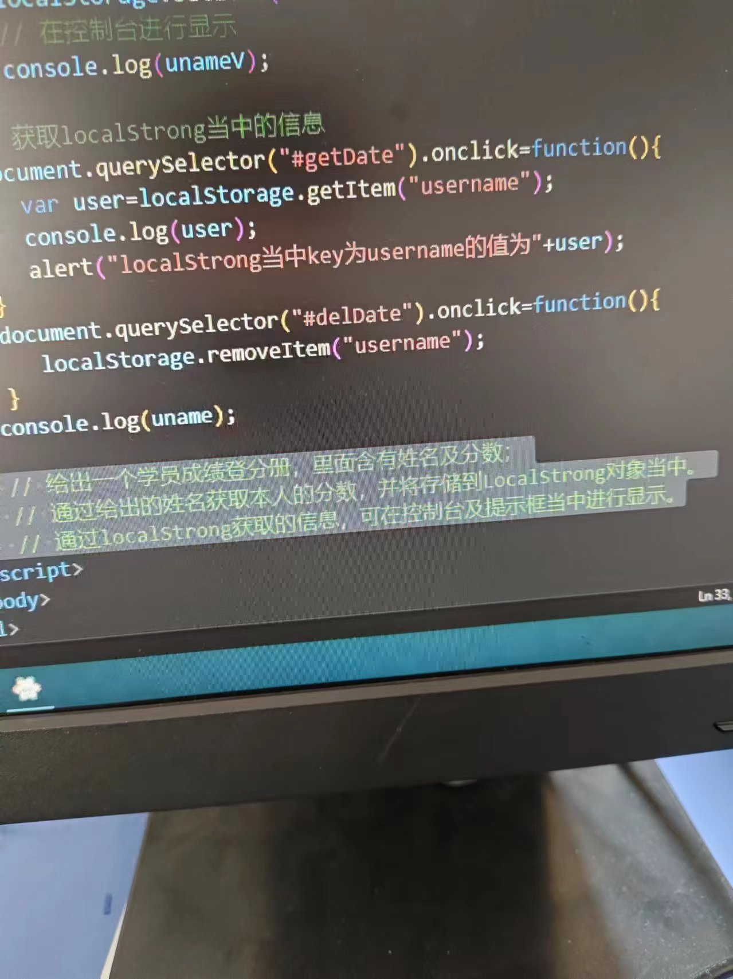

<!DOCTYPE html>

<html>

<body>

<label>姓名</label><input type="text" id="username"maxlength="15"/><br />

<label>成绩</label><input type="number" id="chengji" maxlength="5"/><br />

<button id="save">保存</button><br />

_______________________________<br />

<label>姓名</label><input type="text" id="user1" maxlength="15"/><br />

<button id ="select">查询</button><br />

_______________________________<br />

<script>

document.querySelector('#save').onclick=function(){

    var user=document.getElementById("username").value;

    var cj=document.getElementById("chengji").value;

    localStorage.setItem(user,cj);

}

document.querySelector("#select").onclick=function(){

    var user1=document.getElementById("user1").value;

    var usreT=localStorage.getItem(user1);

    alert(user1+"的成绩是："+usreT);

}

</script>

</body>

</html>

